**Name – Kamal D. Agrahari TE IT - A | Batch – B**

**ID – VU4F2223028 Subject – Adv DevOps Lab**

Experiment No. 1

**Aim:** To understand the benefits of Cloud Infrastructure and Setup AWS Cloud9 IDE, Launch AWS Cloud9 IDE and Perform Collaboration Demonstration.

**Theory**:

AWS Cloud9 is a cloud-based integrated development environment (IDE) that lets you write,

run, and debug your code with just a browser. It includes a code editor, debugger, and

terminal. Cloud9 comes prepackaged with essential tools for popular programming

languages, including JavaScript, Python, PHP, and more, so you don’t need to install files or

configure your development machine to start new projects. Since your Cloud9 IDE is cloud-

based, you can work on your projects from your office, home, or anywhere using an internet-

connected machine. Cloud9 also provides a seamless experience for developing serverless

applications enabling you to easily define resources, debug, and switch between local and

remote execution of serverless applications. With Cloud9, you can quickly share your

development environment with your team, enabling you to pair program and track each

other's inputs in real time.

**Benifits**:

CODE WITH JUST A BROWSER:

AWS Cloud9 gives you the flexibility to run your development environment on a managed

Amazon EC2 instance or any existing Linux server that supports SSH. This means that you

can write, run, and debug applications with just a browser, without needing to install or

maintain a local IDE. The Cloud9 code editor and integrated debugger include helpful,

time-saving features such as code hinting, code completion, and step-through debugging.

The Cloud9 terminal provides a browser- based shell experience enabling you to install

additional software, do a git push, or enter commands.

CODE TOGETHER IN REALTIME:

AWS Cloud9 makes collaborating on code easy. You can share your development environment

with your team in just a few clicks and pair program together. While collaborating, your

team members can see each other type in real time, and instantly chat with one another from

within the IDE.

BUILD SERVERLESS APPLICATIONS WITH EASE

AWS Cloud9 makes it easy to write, run, and debug serverless applications. It

preconfigures the development environment with all the SDKs, libraries, and plug-ins

needed for serverless development. Cloud9 also provides an environment for locally testing

and debugging AWS Lambda functions. This allows you to iterate on your code directly,

saving you time and improving the quality of your code.

DIRECT TERMINALACCESS TO AWS

AWS Cloud9 comes with a terminal that includes sudo privileges to the managed Amazon

EC2 instance that is hosting your development environment and a preauthenticated AWS

Command Line Interface. This makes it easy for you to quickly run commands and directly

access AWS services

START NEW PROJECTS QUICKLY

AWS Cloud9 makes it easy for you to start new projects. Cloud9’s development environment

comes prepackaged with tooling for over 40 programming languages, including Node.js,

JavaScript, Python, PHP, Ruby, Go, and C++. This enables you to start writing code for

popular application stacks within minutes by eliminating the need to install or configure

files, SDKs, and plug-ins for your development machine. Because Cloud9 is cloud-based,

you can easily maintain multiple development environments to isolate your project’s

resources.

**Steps**

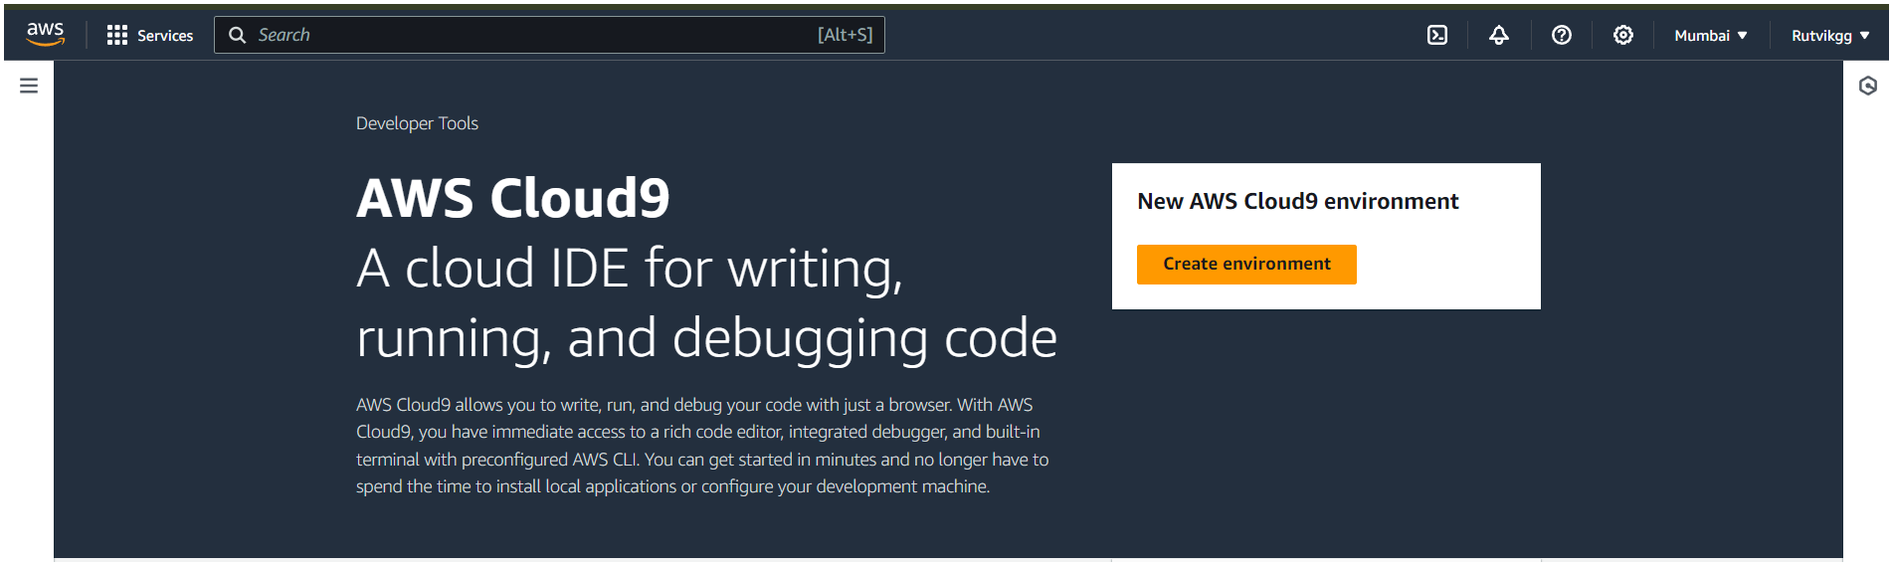1. Search for Cloud9 on AWS Management Console

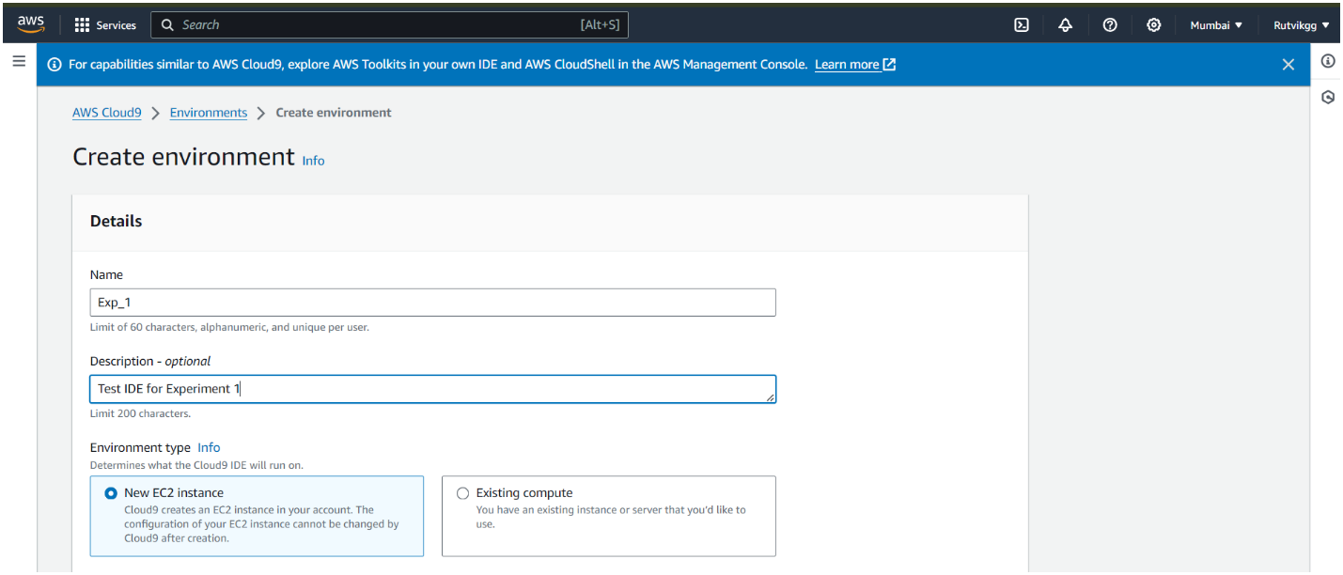2. Enter the name and description for the environment

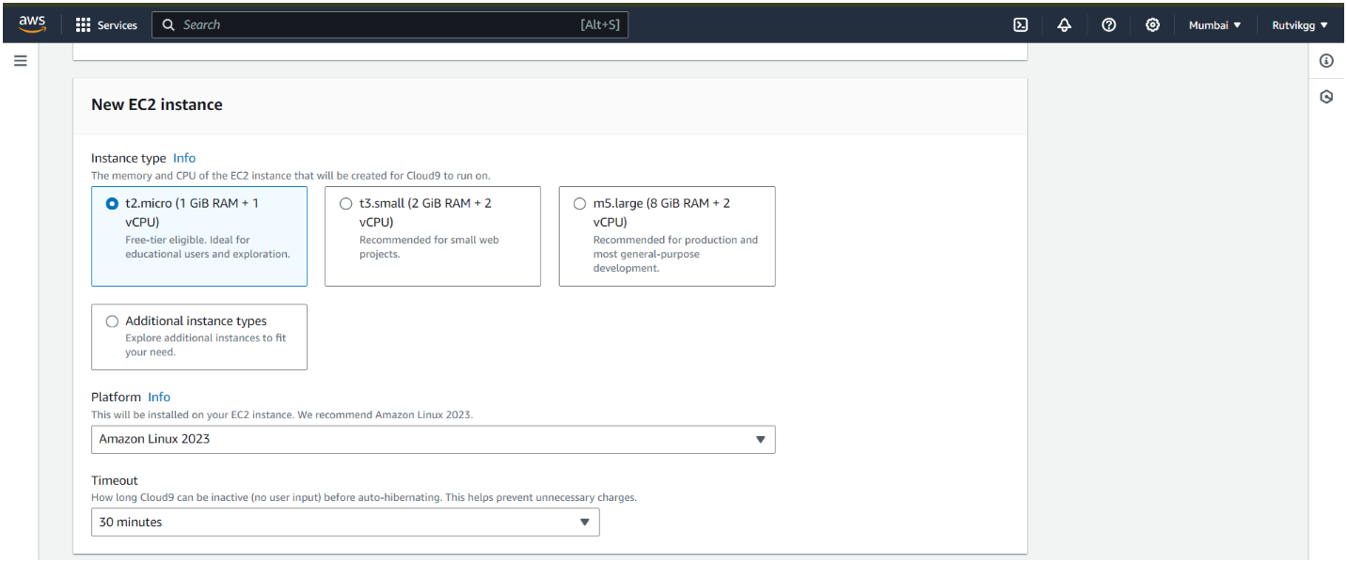3. Keeping the default setting for the EC-2 instance

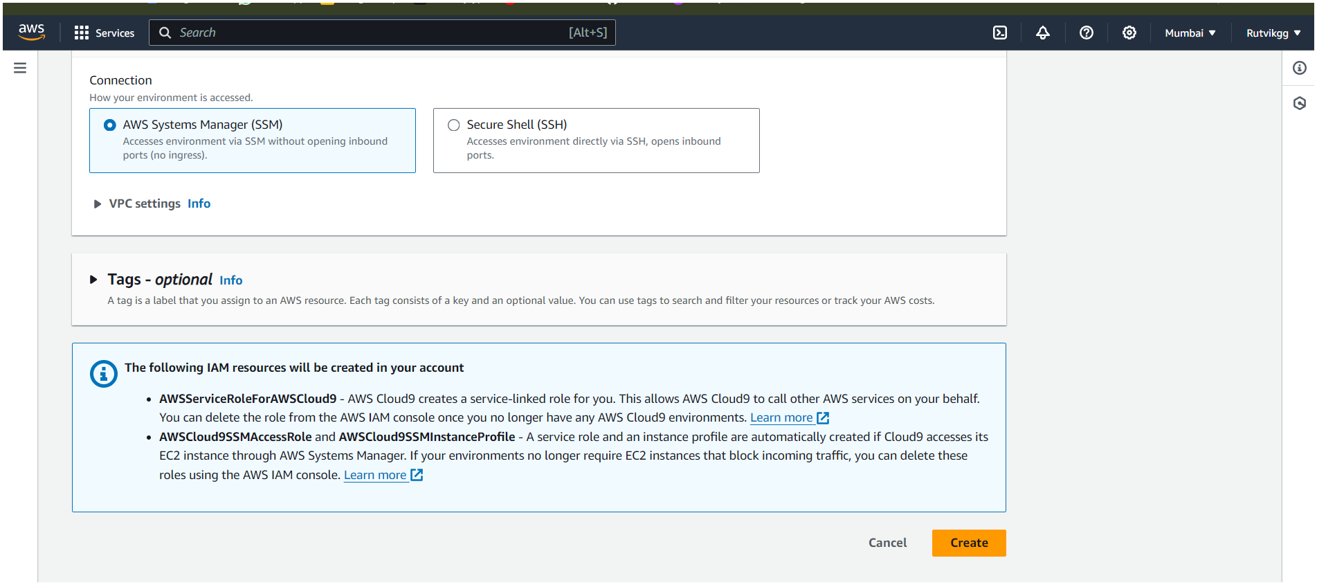4. Click on create button to create your environment

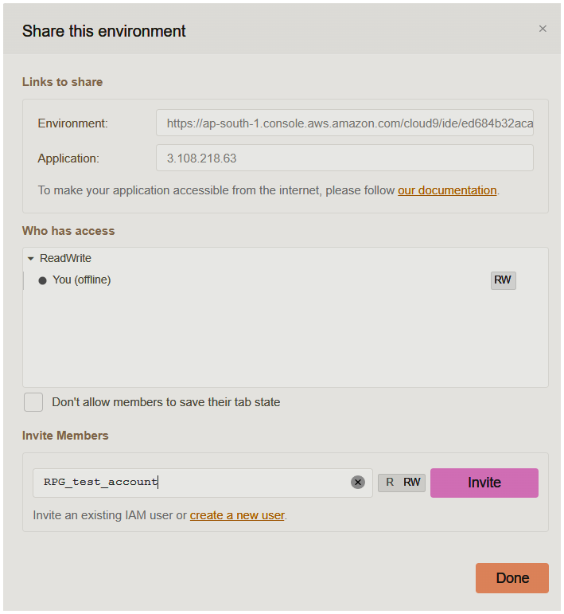5. Your can share the environment using the share tab at the top right corner of the page

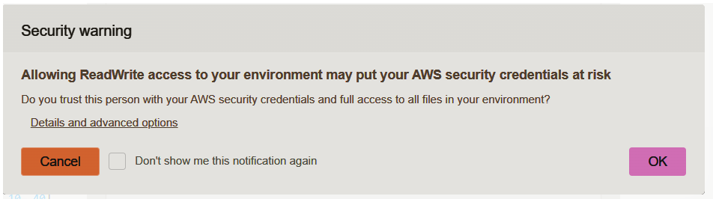6. Check the security warning and click OK

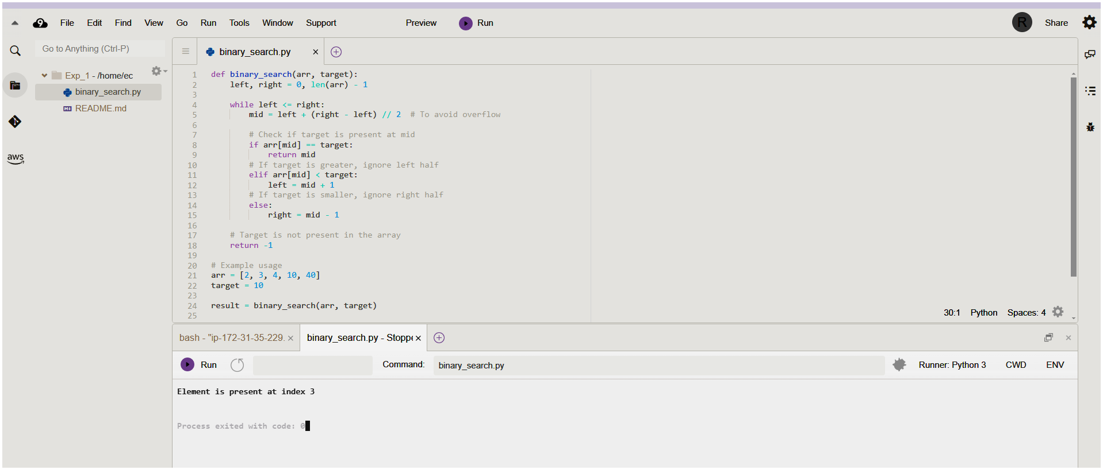7. Write and execute your code in the IDE